Name | ID | Level | Department
احمد ايمن محمد عبدالغفار | 20210032 | 3 | Cs
ابانوب ابراهيم صلاح | 20210002 | 3 | Cs
ابوبكر خالد ابوبكر | 20210011 | 3 | Cs
احمد ابراهيم عبدالله | 20210016 | 3 | Cs
بسملة حسن جاد | 20210223 | 3 | Cs
حبيبة احمد جلال | 20210274 | 3 | Cs
Project Report: KenKen Puzzle Solver

Introduction and Overview:
Project Idea and Overview:
The project aims to solve KenKen puzzles, a mathematical puzzle that combines elements of Sudoku and arithmetic operations. It employs a genetic algorithm approach to find the solution to these puzzles.

Similar Applications:
https://www.kenkenpuzzle.com/

Literature Review:
https://www.academia.edu/download/87608757/94.pdf

https://www.researchgate.net/profile/Alaa-Morsy-3/publication/364338952_A_BLACK_WIDOW_OPTIMIZATION_ALGORITHM_FOR_SOLVING_KENKEN_PROBLEM/links/634bb7dbff870c55ce29082c/A-BLACK-WIDOW-OPTIMIZATION-ALGORITHM-FOR-SOLVING-KENKEN-PROBLEM.pdf

https://www.ncbi.nlm.nih.gov/pmc/articles/PMC1682239/

https://onlinelibrary.wiley.com/doi/abs/10.1002/ps.7917

https://dl.acm.org/doi/abs/10.1145/3017680.3017765

Proposed Solution & Dataset:
Main Functionalities/Features:
Algo1:
The software generates KenKen puzzle solutions based on the input grid size and cage configurations. It utilizes a genetic algorithm to evolve a population of potential solutions to solve the puzzle.
Algo2:
solves kenken by backtrack

Applied Algorithms:
Genetic Algorithm:
Creation of an initial population of potential solutions, Evaluation of fitness based on uniqueness and adherence to cage constraints, Selection, crossover, and mutation to generate new solutions.
Backtrack algorithm:
This Python class, Kenken, is designed to solve Kenken puzzles using a backtracking algorithm. The algorithm enforces constraints on rows, columns, and cage operations to find a valid solution. The class is initialized with a Kenken puzzle defined in an input file, and the solve method is called to find a solution. The solution (if found) or an indication of unsolvability is then printed.

Experiments & Results:
Genetic:
Experimentation and Testing:
# The algorithm underwent testing with various puzzle configurations and population sizes.
# Each generation's best fitness, the evolution of solutions, and convergence patterns were observed.
examples of output:
Sol1: Sol2:
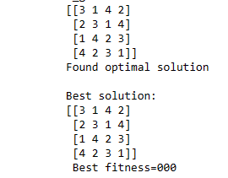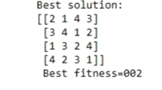

Backtrack:
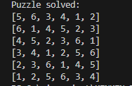
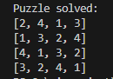

Discussion and Future Work:
Advantages/Disadvantages:
genetic:
# The genetic algorithm tackles KenKen puzzles.
# The approach may struggle with extremely large puzzle sizes or complex constraints.
# it falls at local optima

Backtrack:
# The code solves from 3 to 8 relatively fast.
# The approach may struggle with puzzles greater than 8

Behavior Analysis and Future Modifications:
genetic:
# The algorithm's behavior is influenced by population size, mutation rate, and crossover strategies.
# Future work may involve solving the puzzle without falling at local optima with fitness equals zero
Backtrack:
# Future work may involve changing algorithm to make it solve puzzles greater than 8 relatively fast

Github Repository Link :
https://github.com/Abanoub1111/Project-AI.git

